Virus Protein Interactions in Plants Database (V-Pip db)

Project Proposal

Ritwik Katiyar

Advanced Bioinformatics

Dr.Stuart

8th January 2019

Introduction/ Background

Viruses are small and simple “infectious agents” that use their host cells to multiply. Viruses come in various shapes and sizes and are made of a either DNA or RNA. The nucleic acid sequence can also be single or double stranded DNA or RNA. Viruses also possess the capability to encode various types of proteins ranging from as little as 3-4 proteins to 100-200 proteins. (Lodish) Since, viruses are usually extremely small and have a simple structure, a single virus only contains limited amount of RNA or DNA, in other words a very limited number of genes. Recently studies have found that viruses can not only code for proteins that can be used to simply allow the virus to replicate within a host cell, but also influence the proteins produced by the host cell. (Lodish)

Some of the recent advances in biological research have been the discovery of microRNAs (miRNAs) and small interfering RNAs (siRNAs). Plants and Animals both use small RNAs as guides for posttranscriptional and epigenetic regulation. Both miRNAs and siRNAs share similarity in size, which is about 20-24nt long. (Plaisance) However, siRNAs differ from miRNAs in, precursor structures, pathway of biogenesis and modes of action. miRNAs and siRNAs also play a part in the plant antiviral defense system. One of the most important strategies of plants against viral infections is known as siRNA- mediated gene silencing. SiRNA-mediated gene silencing allows for defensive signal to spread to other neighboring cells otherwise the mechanism itself is similar to the miRNA mediated gene silencing. Plant miRNAs play two main functions in the antiviral defense; miRNAs target the viral RNA/DNA and prevent the virus from reproducing, and miRNAs trigger the synthesis/biogenesis of siRNA (which are responsible for the plant cells primary antiviral response). However, viruses have a counter defense system against the plant cells known as viral suppressors of RNA silencing (VSRs), which interfere with host RNA silencing in multiple ways. (However, VSRs additional functionality includes assistance in viral replication, encapsidation and movement.) VSRs primarily use two methods in dealing with plants defense system; first being the suppression of the assembly of AGOs into RISCs (RNA-induced silencing complex, meant to silence the viral DNA/RNA) and the second being interacting with AGOs to degrade the protein. Viruses that attack plant cells do not encode miRNAs instead most plant viruses encode siRNAs. (VSRs, primarily contains siRNAs, presence of miRNAs have been noticed in few studies however, there is still no definitive proof) (Rui) (Kamthan)

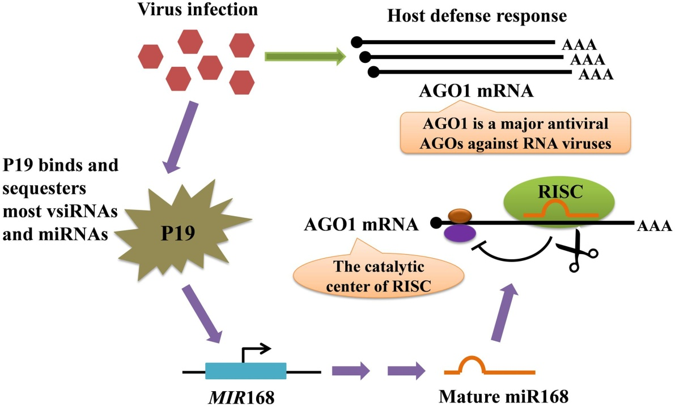

Figure 1: represents a model for the regulation of AGO mRNA level mediated by protein P19-induced miR168. The AGO mRNAs are made when a virus infection is detected within the cell. While the plant cell is creating mRNAs for AGO the virus produces P19 VSR which binds to the virus- encoded siRNAs and with host cell miRNAs which prevents the miRNA loading into AGO. The P19 protein however, does not bind to MIR168 micro RNA (MIR168, represses the AGO1 mRNA); resulting in low production of AGO1 mRNA. (Rui) (Pratt)

Viral Protein Interaction in plants database (V-Pipdb)

Based on the information above, there are various virus and host interactions that researchers have discovered. To document such interactions for further study and to further predict possible interactions could play a huge role in understanding viruses. That knowledge can then be used to develop effective drugs against viral infections. Hence, I propose a database that holds information on interactions between plant and plant viruses’ proteins. Animal viruses are being avoided since there are already a significant amount of databases for them and Animals natural anti-viral mechanism is extremely complex. Similarly all unicellular organisms are being avoided due to lack of information on anti-viral mechanism currently present. Viral Interaction in plants database (V-Pipdb) would collect information on plant viruses’ (primarily viruses that infect agricultural crops) proteins that interact with miRNA/ siRNAs. This would be true for every plant in the database. No other database poses such capabilities; hence this database would be rather unique. From this project I hope to learn more about database creation, management, and collecting data from databases and sorting that data to function for my purpose. Along with learning about the problems that might arise from creating and maintaining a database

For example: Tombus-virus infects tomato plants and, the virus itself does not code for any siRNAs. However, the virus does code for a protein named P19 which interacts with host cells siRNAs and interferes with the plants ability to counteract the virus as mentioned in the introduction.

Outline

This section will show the behind the scenes programming and the order in which the programming will be done. Also provides information on challenges that will be faced along with solution to said challenges.

1. ‘Popular’ (meaning plants with a high yield) plants that are agriculturally grown around the world, would selected along with viruses that infect the selected plants. To determine what ‘Popular’ plants are agriculturally, a data set from food and agricultural organization will be selected and organized based on the amount of yield.
2. Then the top 50 plants will be selected. When the plants are first recorded, any and all species related to the genus. Example: Oryza (Rice) would include: Oryza australiensis, Oryza barthii, Oryza cubensis, etc.
3. Once the plants have been selected then the plants will be searched on Plant Viruses Onlineand all viruses that infect said plants will be selected and moved to V-Pipdb (my database).
4. Once the viruses and the plants have been selected. The next step would be to find proteins based on the virus that was selected by the user. To do that the virus will simply be searched in P-fam and any associated viruses proteins that are found will be displayed to the user.
5. Final step would be for the database to “flag” siRNA/miRNA interacting proteins to the user. For that, the proteins will be searched for a specific conserved motif using motif scan tool which will search for iRNA interaction motifs. If any such motifs are detected the protein will be flagged.

All of this will be done on mySQL except for step 1 and 2; they will be done in Python. The database would contain the following data => My-Database (Plant Genus, Plant Species, Plant Virus, Viral-Proteins). The plant Genus would lead to plant species, the plant species would lead to plant virus, then plant virus to viral proteins associated with the virus. Mostly likely the database will be in the 4th NF and not in BSNL form.

User Interface - Flow Chart

Figure 2: shows the flow chart in order to organize the information on what the user will see and what will be included in the database.

References

1. (Skalsky)Skalsky, Rebecca L and Bryan R Cullen. “Viruses, microRNAs, and host interactions” *Annual review of microbiology* vol. 64 (2010): 123-41.
2. (Plaisance)Plaisance-Bonstaff K, Renne R. [Viral miRNAs.](https://www.ncbi.nlm.nih.gov/pubmed/21431678) Methods Mol Biol. 2011;721:43-66. doi: 10.1007/978-1-61779-037-9_3. Review. PubMed PMID: 21431678.
3. (Lodish)Lodish H, Berk A, Zipursky SL, et al. Molecular Cell Biology. 4th edition. New York: W. H. Freeman; 2000. Section 6.3, Viruses: Structure, Function, and Uses. Available from: <https://www.ncbi.nlm.nih.gov/books/NBK21523/>
4. (Pratt)Pratt, Ashley J and Ian J MacRae. “The RNA-induced silencing complex: a versatile gene-silencing machine” *Journal of biological chemistry* vol. 284,27 (2009): 17897-901.
5. (Kamthan)Kamthan, Ayushi et al. “Small RNAs in plants: recent development and application for crop improvement” *Frontiers in plant science* vol. 6 208. 2 Apr. 2015, doi:10.3389/fpls.2015.00208
6. (Sulin)Sulin Lou, TingSun, HuiLi and Zhangli Hu et al. “Mechanisms of MicroRNA-Mediated Gene Regulation in Unicellular Model Alga Chlamydomonas Reinhardtii.” *Biotechnology for Biofuels*, BioMed Central, 8 Sept. 2018, biotechnologyforbiofuels.biomedcentral.com/articles/10.1186/s13068-018-1249-y.
7. (Rui) Rui, Liu Sheng, et al. “MicroRNA-Mediated Gene Silencing in Plant Defense and Viral Counter-Defense .” *Frontiers in Microbiology* , vol. 08, no. 1664-302x, 2017, p. 1801., doi:10.3389/fmicb.2017.01801.